**Homework Layouting UI & Responsive UI**

* **Landing Page**

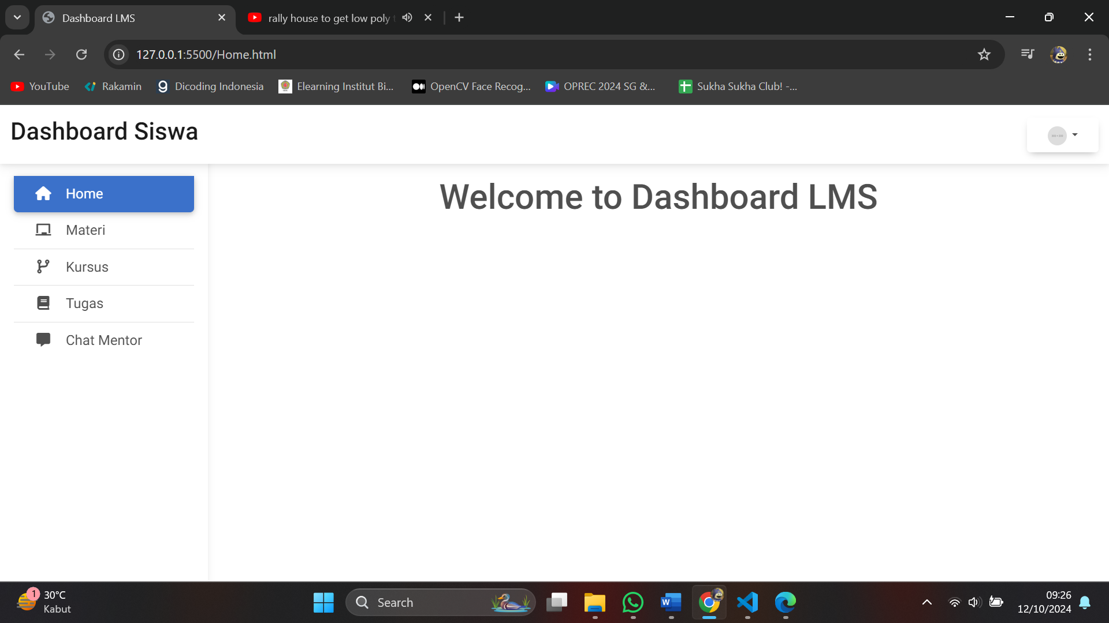

* **Page Materi**

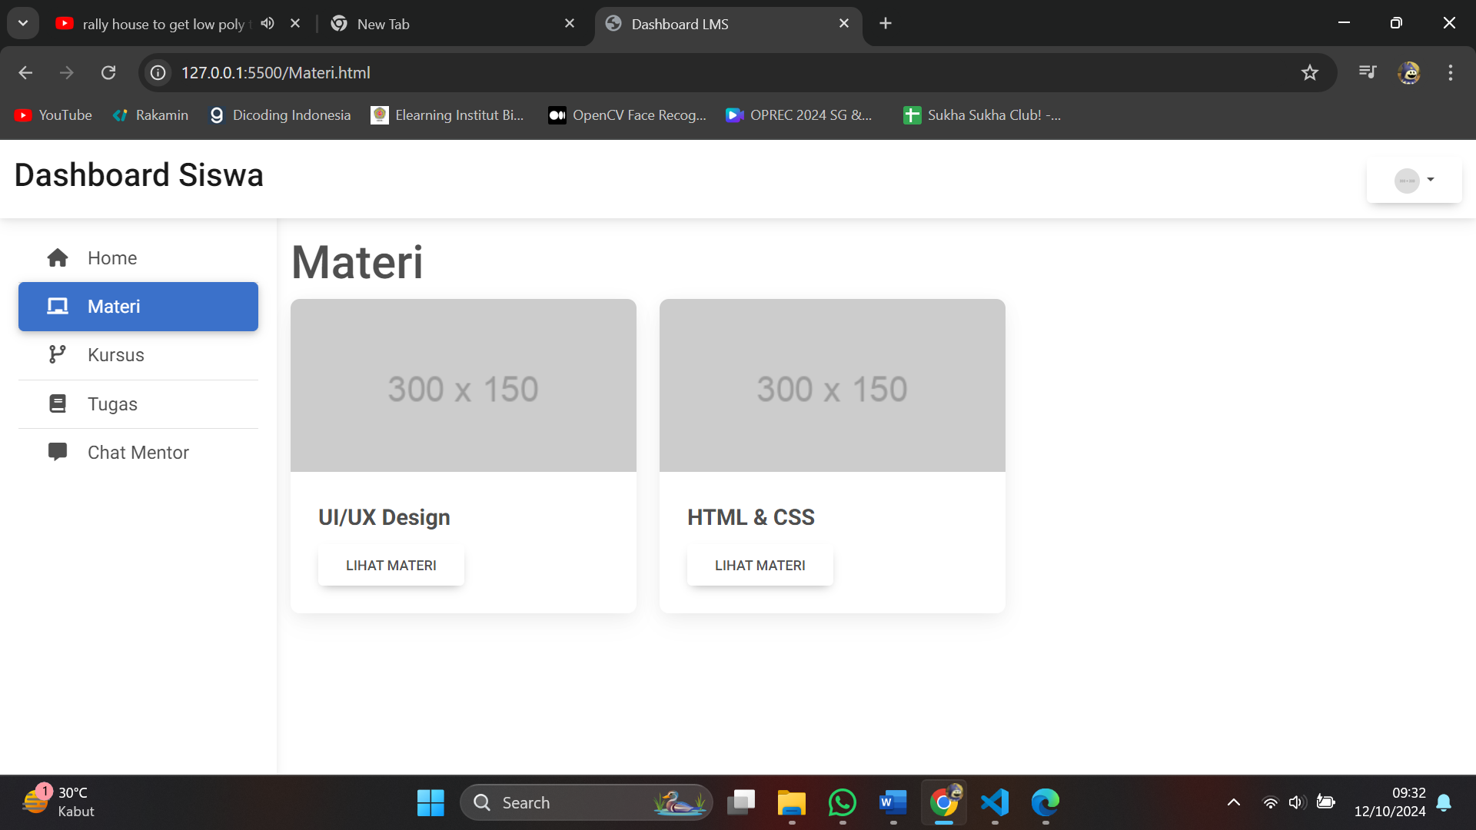

* **Page Kursus**

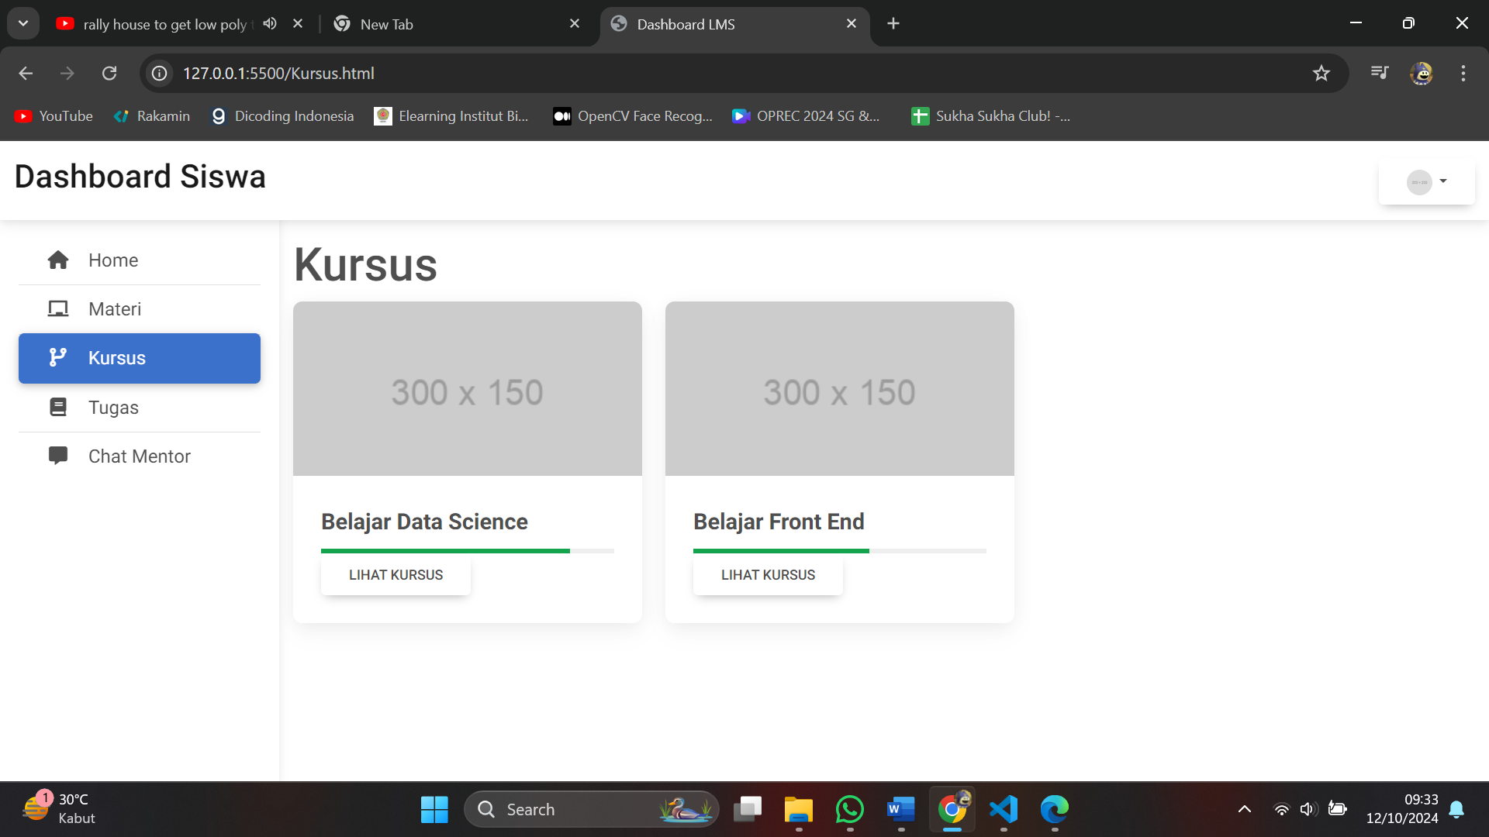

* **Page Tugas**

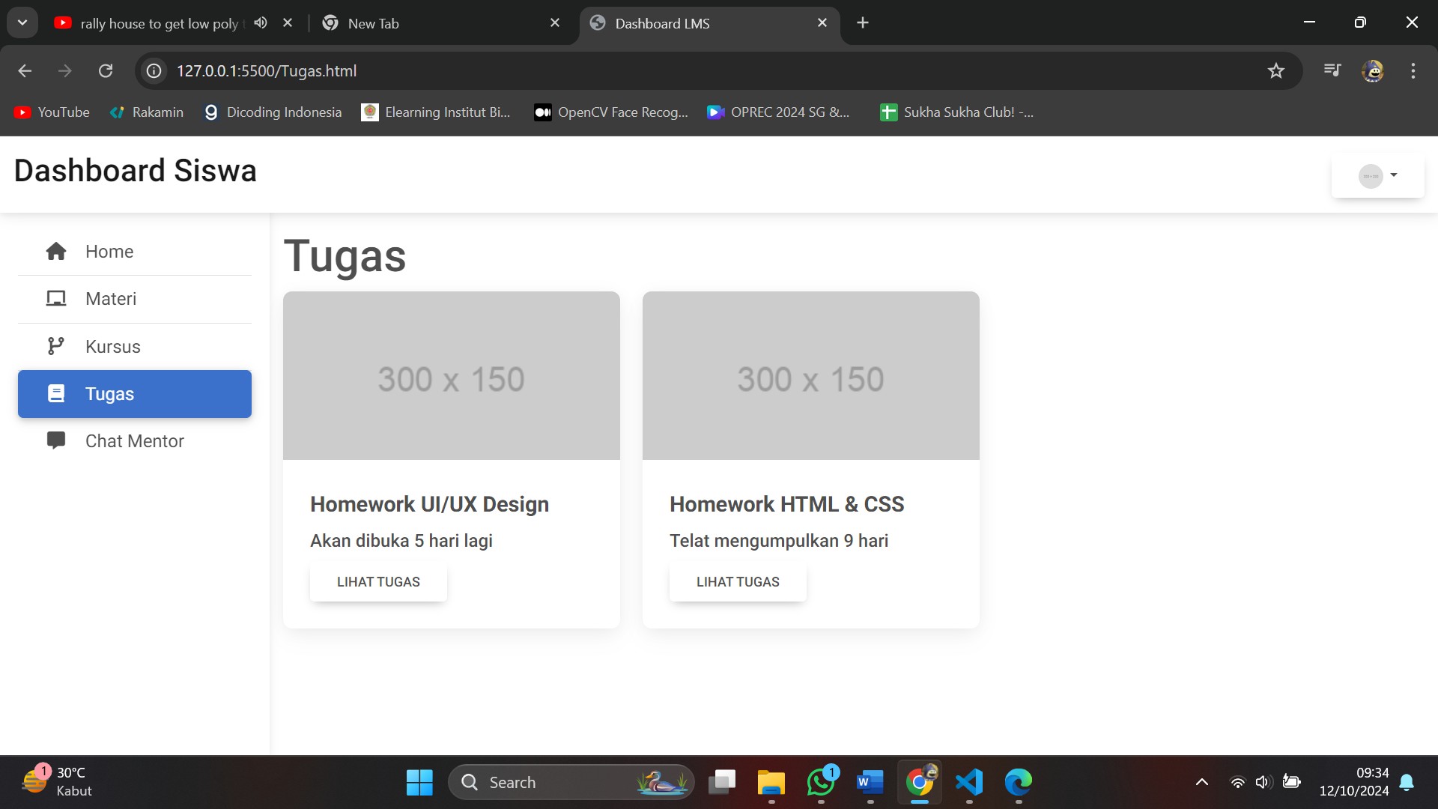

* **Page Chat Mentor**

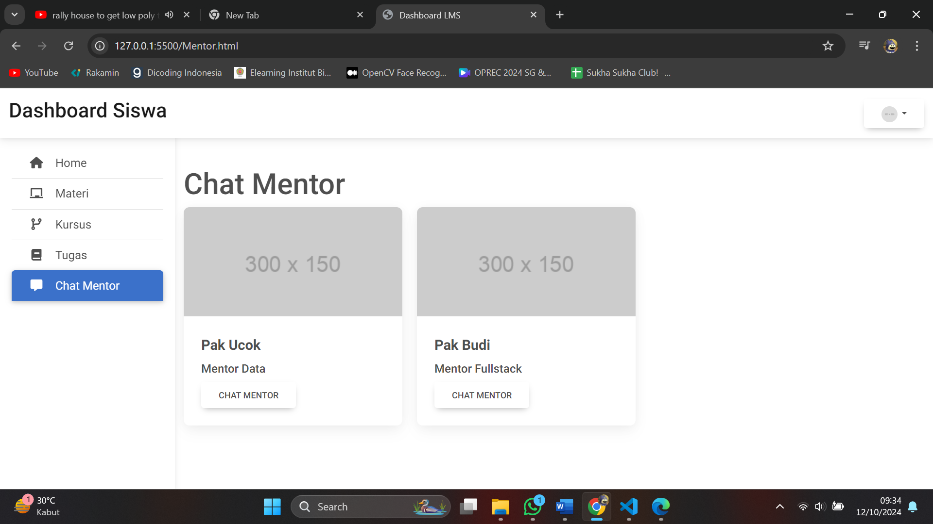

* **Button Profile**

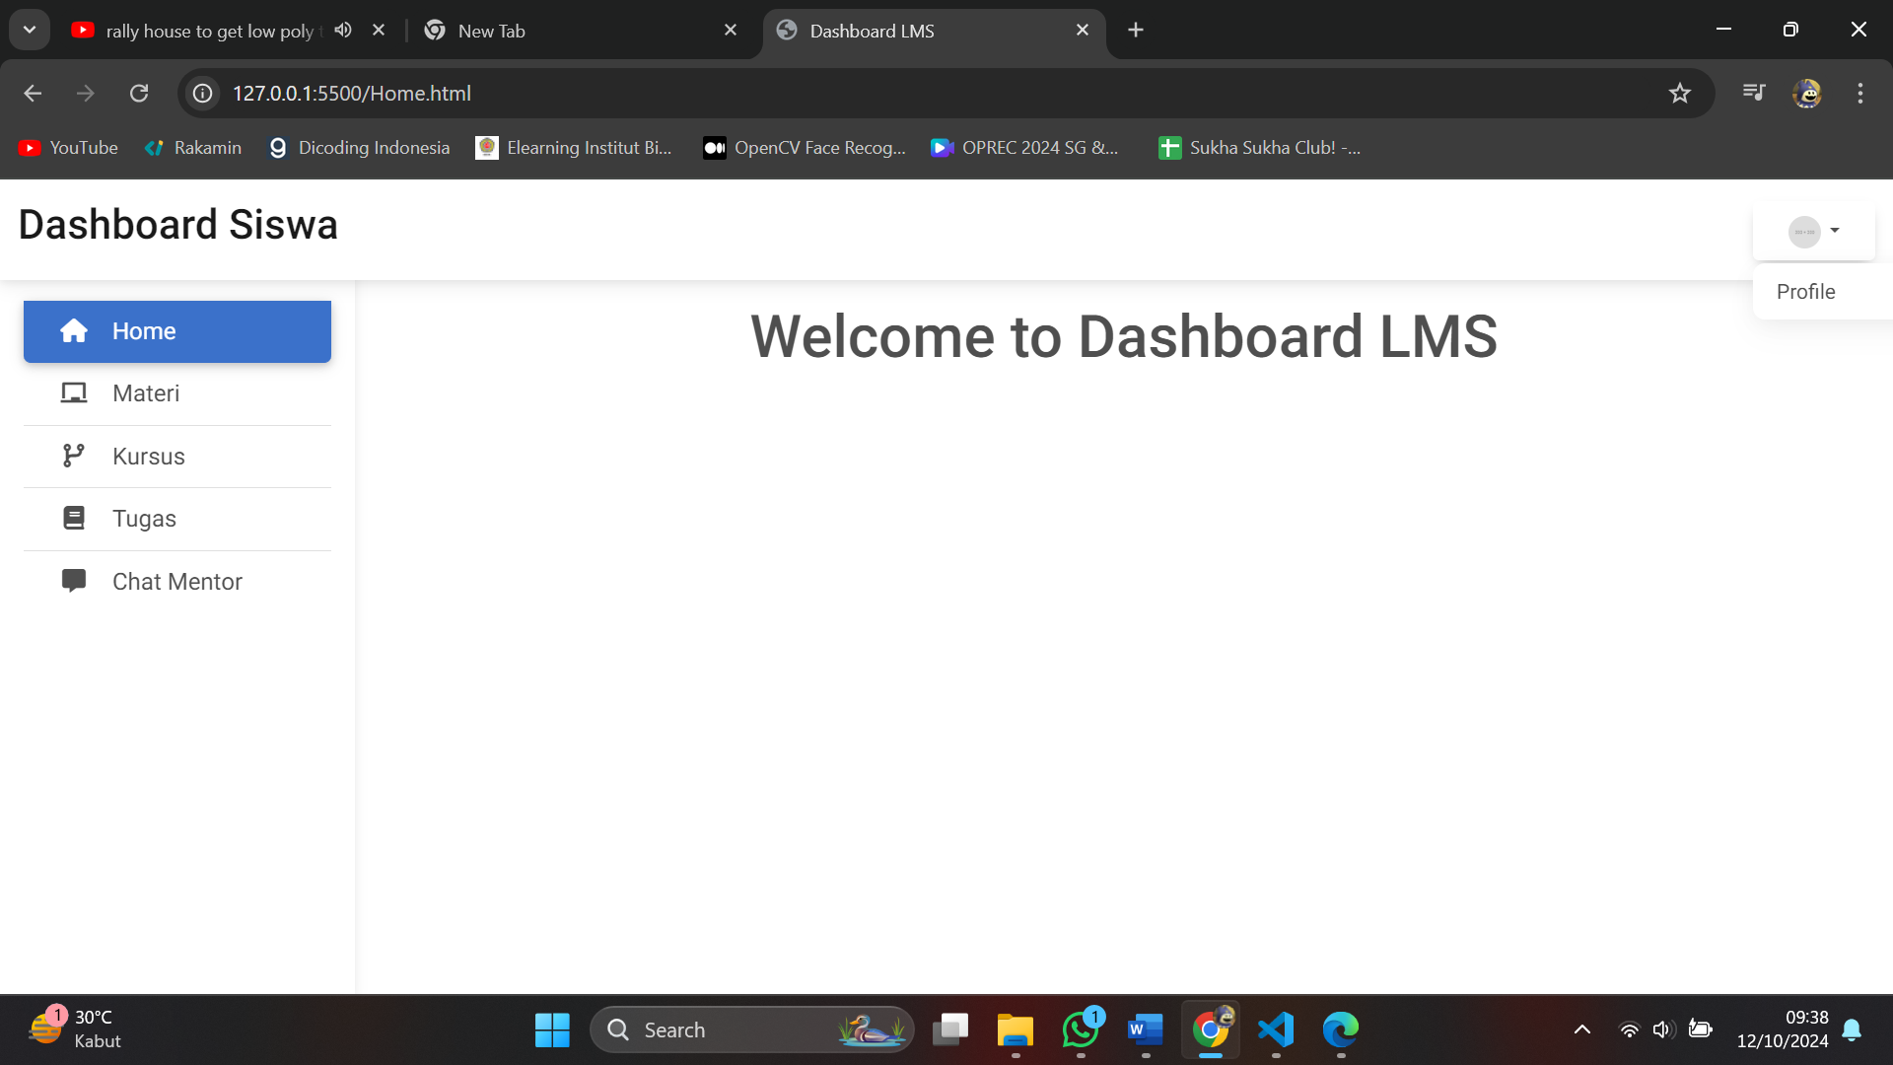

**Responsive :**

* **Laptop :**

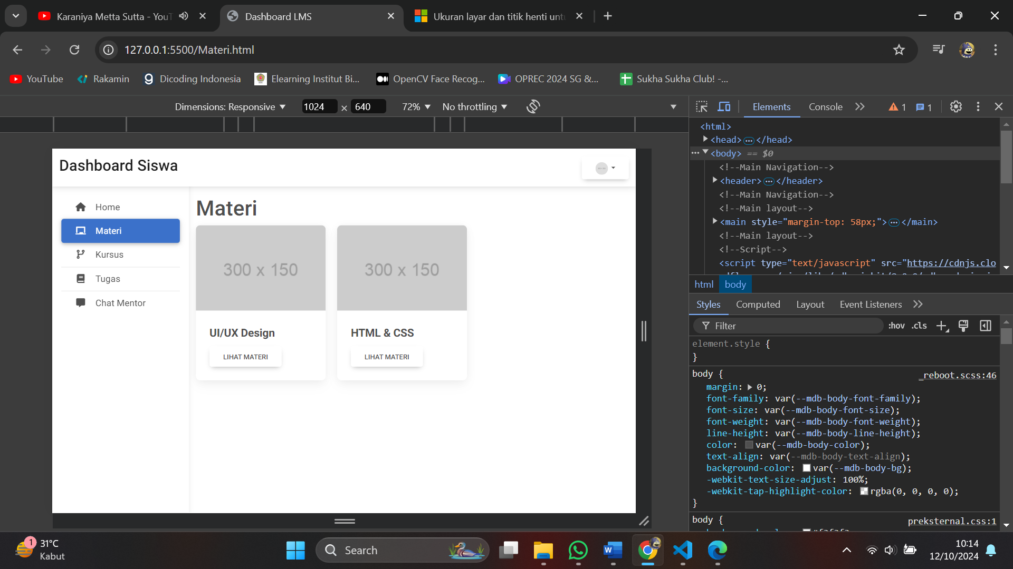

* **Tab :**

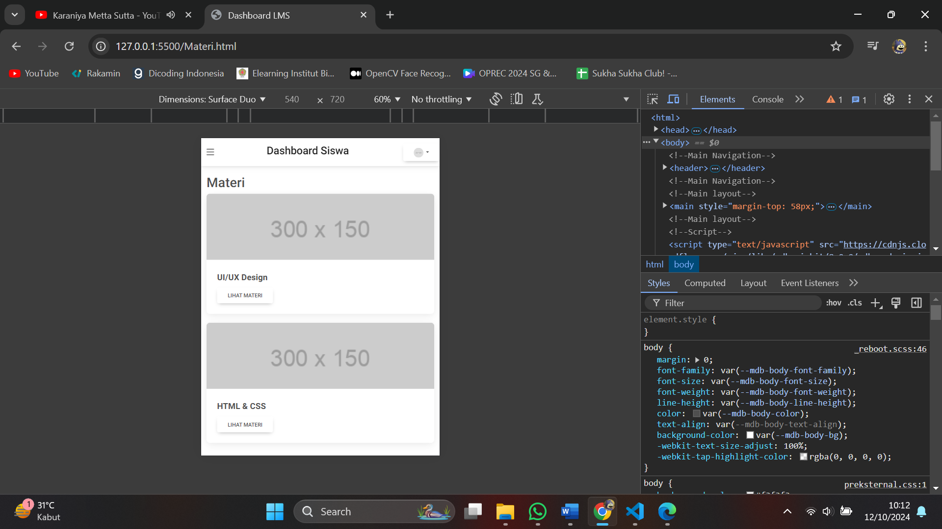

* **Handphone :**

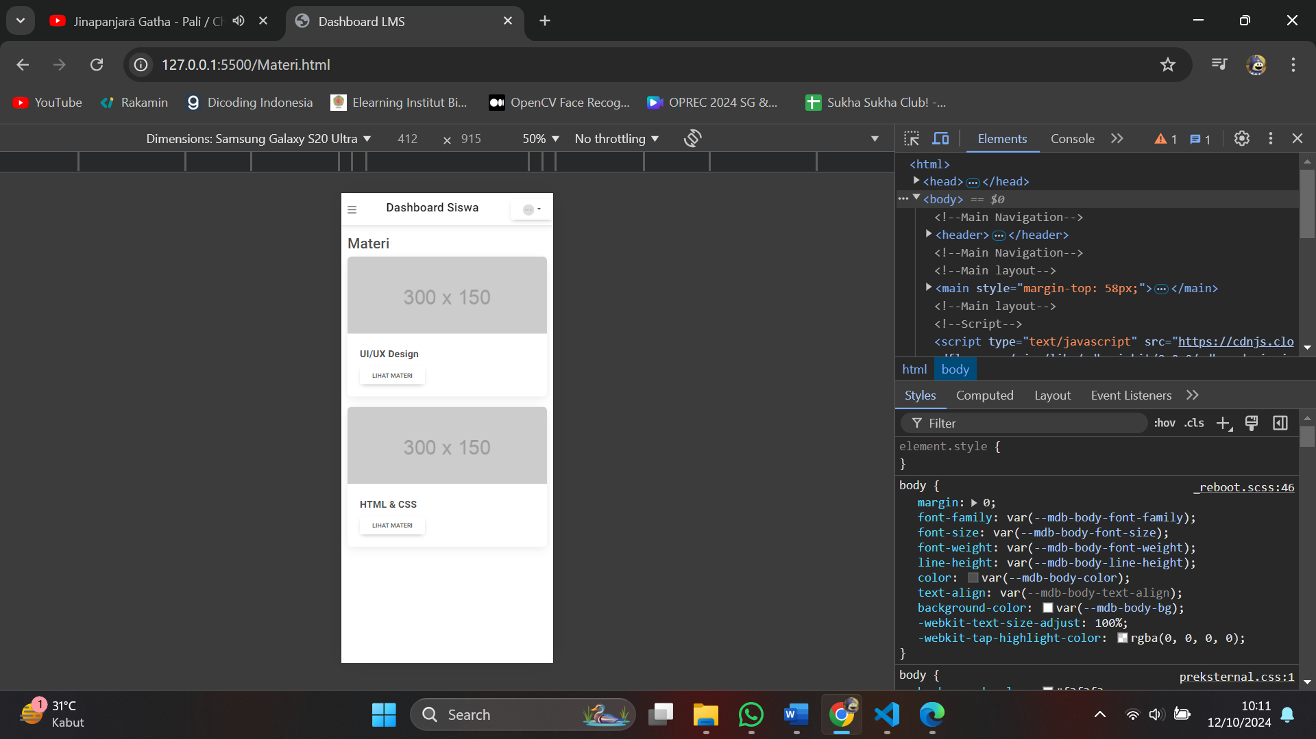

**Kode :**

* **HTML**
* Home.html :

<html>

<head>

<meta charset="UTF-8"/>

<meta name="viewport" content="width=device-width, initial-scae=1.0"/> <!--Memastikan tampilan halaman responsif pada berbagai ukuran layar-->

<link rel="stylesheet" href="https://cdn.jsdelivr.net/npm/bootstrap@4.4.1/dist/css/bootstrap.min.css" integrity="sha384-Vkoo8x4CGsO3+Hhxv8T/Q5PaXtkKtu6ug5TOeNV6gBiFeWPGFN9MuhOf23Q9Ifjh" crossorigin="anonymous"> <!--Link Library Bootstrap-->

<link rel="stylesheet" href="preksternal.css">

<!-- Font Awesome -->

<link

href="https://cdnjs.cloudflare.com/ajax/libs/font-awesome/6.0.0/css/all.min.css"

rel="stylesheet"

/> <!-- Link untuk memuat ikon Font Awesome -->

<!-- Google Fonts -->

<link

href="https://fonts.googleapis.com/css?family=Roboto:300,400,500,700&display=swap"

rel="stylesheet"

/> <!--Link untuk menggunakan font Google, khususnya Roboto-->

<!-- MDB -->

<link

href="https://cdnjs.cloudflare.com/ajax/libs/mdb-ui-kit/8.0.0/mdb.min.css"

rel="stylesheet"

/> <!--Link ke library CSS MDB-->

<title>Dashboard LMS</title> <!--Title-->

</head>

<body>

<!--Main Navigation-->

<header>

<!-- Sidebar -->

<nav id="sidebarMenu" class="collapse d-lg-block sidebar collapse bg-white">

<div class="position-sticky">

<div class="list-group list-group-flush mx-3 mt-4">

<a href="Home.html" class="list-group-item list-group-item-action py-2 ripple active">

<i class="fas fa-house fa-fw me-3"></i><span>Home</span>

</a> <!--Active-->

<a href="Materi.html" class="list-group-item list-group-item-action py-2 ripple">

<i class="fas fa-chalkboard fa-fw me-3"></i><span>Materi</span>

</a>

<a href="Kursus.html" class="list-group-item list-group-item-action py-2 ripple"><i

class="fas fa-code-branch fa-fw me-3"></i><span>Kursus</span></a>

<a href="Tugas.html" class="list-group-item list-group-item-action py-2 ripple"><i

class="fas fa-book fa-fw me-3"></i><span>Tugas</span></a>

<a href="Mentor.html" class="list-group-item list-group-item-action py-2 ripple">

<i class="fas fa-message fa-fw me-3"></i><span>Chat Mentor</span>

</a>

</div>

</div>

</nav>

<!-- Sidebar -->

<!-- Navbar -->

<nav id="main-navbar" class="navbar navbar-expand-lg navbar-light bg-white fixed-top">

<!-- Container wrapper -->

<div class="container-fluid">

<!-- Toggle button -->

<button data-mdb-button-init class="navbar-toggler" type="button" data-mdb-collapse-init data-mdb-target="#sidebarMenu"

aria-controls="sidebarMenu" aria-expanded="false" aria-label="Toggle navigation">

<i class="fas fa-bars"></i>

</button>

<!-- Brand -->

<a class="navbar-brand" href="Home.html">

<h3>Dashboard Siswa</h3>

</a> <!--Menampilkan teks "Dashboard Siswa" sebagai identitas web-->

<!-- Profile -->

<div class="container-profile">

<div class="btn-group">

<button type="button" class="btn btn dropdown-toggle dropdown-toggle split" data-toggle="dropdown" aria-haspopup="true" aria-expanded="false">

<img src="https://placehold.co/300x300/png" class="rounded-circle"

height="22" alt="Profile" loading="lazy" />

</button> <!--Dropdown yang menampilkan gambar avatar (placeholder image 300x300)-->

<div class="dropdown-menu dropdown-menu-right">

<button class="dropdown-item" type="button">Profile</button>

</div>

</div>

</div>

</div>

<!-- Container wrapper -->

</nav>

<!-- Navbar -->

</header>

<!--Main Navigation-->

<!--Main layout-->

<main style="margin-top: 58px;"> <!--Memuat konten utama halaman-->

<div class="container pt-4">

<h1 class="welcome">Welcome to Dashboard LMS</h1>

</div>

</main>

<!--Main layout-->

<!--Script--> <!--Memuat pustaka JavaScript Bootstrap dan dari Material Design for Bootstrap (MDB)-->

<script

type="text/javascript"

src="https://cdnjs.cloudflare.com/ajax/libs/mdb-ui-kit/8.0.0/mdb.umd.min.js"

></script>

<script src="https://code.jquery.com/jquery-3.4.1.slim.min.js" integrity="sha384-J6qa4849blE2+poT4WnyKhv5vZF5SrPo0iEjwBvKU7imGFAV0wwj1yYfoRSJoZ+n" crossorigin="anonymous"></script>

<script src="https://cdn.jsdelivr.net/npm/popper.js@1.16.0/dist/umd/popper.min.js" integrity="sha384-Q6E9RHvbIyZFJoft+2mJbHaEWldlvI9IOYy5n3zV9zzTtmI3UksdQRVvoxMfooAo" crossorigin="anonymous"></script>

<script src="https://cdn.jsdelivr.net/npm/bootstrap@4.4.1/dist/js/bootstrap.min.js" integrity="sha384-wfSDF2E50Y2D1uUdj0O3uMBJnjuUD4Ih7YwaYd1iqfktj0Uod8GCExl3Og8ifwB6" crossorigin="anonymous"></script>

</body>

</html>

* Materi.html

<html>

<head>

<meta charset="UTF-8"/>

<meta name="viewport" content="width=device-width, initial-scae=1.0"/> <!--Memastikan tampilan halaman responsif pada berbagai ukuran layar-->

<link rel="stylesheet" href="https://cdn.jsdelivr.net/npm/bootstrap@4.4.1/dist/css/bootstrap.min.css" integrity="sha384-Vkoo8x4CGsO3+Hhxv8T/Q5PaXtkKtu6ug5TOeNV6gBiFeWPGFN9MuhOf23Q9Ifjh" crossorigin="anonymous"> <!--Link Library Bootstrap-->

<link rel="stylesheet" href="preksternal.css">

<!-- Font Awesome -->

<link

href="https://cdnjs.cloudflare.com/ajax/libs/font-awesome/6.0.0/css/all.min.css"

rel="stylesheet"

/> <!-- Link untuk memuat ikon Font Awesome -->

<!-- Google Fonts -->

<link

href="https://fonts.googleapis.com/css?family=Roboto:300,400,500,700&display=swap"

rel="stylesheet"

/> <!--Link untuk menggunakan font Google, khususnya Roboto-->

<!-- MDB -->

<link

href="https://cdnjs.cloudflare.com/ajax/libs/mdb-ui-kit/8.0.0/mdb.min.css"

rel="stylesheet"

/> <!--Link ke library CSS MDB-->

<title>Dashboard LMS</title> <!--Title-->

</head>

<body>

<!--Main Navigation-->

<header>

<!-- Sidebar -->

<nav id="sidebarMenu" class="collapse d-lg-block sidebar collapse bg-white">

<div class="position-sticky">

<div class="list-group list-group-flush mx-3 mt-4">

<a href="Home.html" class="list-group-item list-group-item-action py-2 ripple">

<i class="fas fa-house fa-fw me-3"></i><span>Home</span>

</a>

<a href="Materi.html" class="list-group-item list-group-item-action py-2 ripple active">

<i class="fas fa-chalkboard fa-fw me-3"></i><span>Materi</span>

</a> <!--Active-->

<a href="Kursus.html" class="list-group-item list-group-item-action py-2 ripple"><i

class="fas fa-code-branch fa-fw me-3"></i><span>Kursus</span></a>

<a href="Tugas.html" class="list-group-item list-group-item-action py-2 ripple"><i

class="fas fa-book fa-fw me-3"></i><span>Tugas</span></a>

<a href="Mentor.html" class="list-group-item list-group-item-action py-2 ripple">

<i class="fas fa-message fa-fw me-3"></i><span>Chat Mentor</span>

</a>

</div>

</div>

</nav>

<!-- Sidebar -->

<!-- Navbar -->

<nav id="main-navbar" class="navbar navbar-expand-lg navbar-light bg-white fixed-top">

<!-- Container wrapper -->

<div class="container-fluid">

<!-- Toggle button -->

<button data-mdb-button-init class="navbar-toggler" type="button" data-mdb-collapse-init data-mdb-target="#sidebarMenu"

aria-controls="sidebarMenu" aria-expanded="false" aria-label="Toggle navigation">

<i class="fas fa-bars"></i>

</button>

<!-- Brand -->

<a class="navbar-brand" href="Home.html">

<h3>Dashboard Siswa</h3>

</a> <!--Menampilkan teks "Dashboard Siswa" sebagai identitas web-->

<!-- Profile -->

<div class="container-profile">

<div class="btn-group">

<button type="button" class="btn btn dropdown-toggle dropdown-toggle split" data-toggle="dropdown" aria-haspopup="true" aria-expanded="false">

<img src="https://placehold.co/300x300/png" class="rounded-circle"

height="22" alt="Profile" loading="lazy" />

</button> <!--Dropdown yang menampilkan gambar avatar (placeholder image 300x300)-->

<div class="dropdown-menu dropdown-menu-right">

<button class="dropdown-item" type="button">Profile</button>

</div>

</div>

</div>

</div>

</div>

<!-- Container wrapper -->

</nav>

<!-- Navbar -->

</header>

<!--Main Navigation-->

<!--Main layout-->

<main style="margin-top: 58px;"> <!--Memuat konten utama halaman-->

<div class="container pt-4">

<h1>Materi</h1>

<div class="card-container">

<!-- Card Pertama -->

<div class="card">

<img src="https://via.placeholder.com/300x150" alt="IT Fullstack Developer">

<div class="card-body">

<div class="card-title">UI/UX Design</div>

<a href="#" class="btn">Lihat Materi</a>

</div>

</div>

<!-- Card Kedua -->

<div class="card">

<img src="https://via.placeholder.com/300x150" alt="Another Course">

<div class="card-body">

<div class="card-title">HTML & CSS</div>

<a href="#" class="btn">Lihat Materi</a>

</div>

</div>

</div>

</div>

</main>

<!--Main layout-->

<!--Script--> <!--Memuat pustaka JavaScript Bootstrap dan dari Material Design for Bootstrap (MDB)-->

<script

type="text/javascript"

src="https://cdnjs.cloudflare.com/ajax/libs/mdb-ui-kit/8.0.0/mdb.umd.min.js"

></script>

<script src="https://code.jquery.com/jquery-3.4.1.slim.min.js" integrity="sha384-J6qa4849blE2+poT4WnyKhv5vZF5SrPo0iEjwBvKU7imGFAV0wwj1yYfoRSJoZ+n" crossorigin="anonymous"></script>

<script src="https://cdn.jsdelivr.net/npm/popper.js@1.16.0/dist/umd/popper.min.js" integrity="sha384-Q6E9RHvbIyZFJoft+2mJbHaEWldlvI9IOYy5n3zV9zzTtmI3UksdQRVvoxMfooAo" crossorigin="anonymous"></script>

<script src="https://cdn.jsdelivr.net/npm/bootstrap@4.4.1/dist/js/bootstrap.min.js" integrity="sha384-wfSDF2E50Y2D1uUdj0O3uMBJnjuUD4Ih7YwaYd1iqfktj0Uod8GCExl3Og8ifwB6" crossorigin="anonymous"></script>

</body>

</html>

* Kursus.html

<html>

  <head>

    <meta charset="UTF-8"/>

    <meta name="viewport" content="width=device-width, initial-scae=1.0"/> <!--Memastikan tampilan halaman responsif pada berbagai ukuran layar-->

    <link rel="stylesheet" href="https://cdn.jsdelivr.net/npm/bootstrap@4.4.1/dist/css/bootstrap.min.css" integrity="sha384-Vkoo8x4CGsO3+Hhxv8T/Q5PaXtkKtu6ug5TOeNV6gBiFeWPGFN9MuhOf23Q9Ifjh" crossorigin="anonymous"> <!--Link Library Bootstrap-->

    <link rel="stylesheet" href="preksternal.css">

    <!-- Font Awesome -->

    <link

    href="https://cdnjs.cloudflare.com/ajax/libs/font-awesome/6.0.0/css/all.min.css"

    rel="stylesheet"

    /> <!-- Link untuk memuat ikon Font Awesome -->

    <!-- Google Fonts -->

    <link

    href="https://fonts.googleapis.com/css?family=Roboto:300,400,500,700&display=swap"

    rel="stylesheet"

    /> <!--Link untuk menggunakan font Google, khususnya Roboto-->

    <!-- MDB -->

    <link

    href="https://cdnjs.cloudflare.com/ajax/libs/mdb-ui-kit/8.0.0/mdb.min.css"

    rel="stylesheet"

    /> <!--Link ke library CSS MDB-->

    <title>Dashboard LMS</title> <!--Title-->

</head>

<body>

<!--Main Navigation-->

<header>

    <!-- Sidebar -->

    <nav id="sidebarMenu" class="collapse d-lg-block sidebar collapse bg-white">

      <div class="position-sticky">

        <div class="list-group list-group-flush mx-3 mt-4">

          <a href="Home.html" class="list-group-item list-group-item-action py-2 ripple">

            <i class="fas fa-house fa-fw me-3"></i><span>Home</span>

          </a>

          <a href="Materi.html" class="list-group-item list-group-item-action py-2 ripple">

            <i class="fas fa-chalkboard fa-fw me-3"></i><span>Materi</span>

          </a>

          <a href="Kursus.html" class="list-group-item list-group-item-action py-2 ripple active"><i

              class="fas fa-code-branch fa-fw me-3"></i><span>Kursus</span></a> <!--Active-->

          <a href="Tugas.html" class="list-group-item list-group-item-action py-2 ripple"><i

              class="fas fa-book fa-fw me-3"></i><span>Tugas</span></a>

          <a href="Mentor.html" class="list-group-item list-group-item-action py-2 ripple">

            <i class="fas fa-message fa-fw me-3"></i><span>Chat Mentor</span>

          </a>

        </div>

      </div>

    </nav>

    <!-- Sidebar -->

    <!-- Navbar -->

    <nav id="main-navbar" class="navbar navbar-expand-lg navbar-light bg-white fixed-top">

      <!-- Container wrapper -->

      <div class="container-fluid">

        <!-- Toggle button -->

        <button data-mdb-button-init class="navbar-toggler" type="button" data-mdb-collapse-init data-mdb-target="#sidebarMenu"

          aria-controls="sidebarMenu" aria-expanded="false" aria-label="Toggle navigation">

          <i class="fas fa-bars"></i>

        </button>

        <!-- Brand -->

        <a class="navbar-brand" href="Home.html">

          <h3>Dashboard Siswa</h3>

        </a> <!--Menampilkan teks "Dashboard Siswa" sebagai identitas web-->

        <!-- Profile -->

        <div class="container-profile">

          <div class="btn-group">

            <button type="button" class="btn btn dropdown-toggle dropdown-toggle split" data-toggle="dropdown" aria-haspopup="true" aria-expanded="false">

                <img src="https://placehold.co/300x300/png" class="rounded-circle"

                height="22" alt="Profile" loading="lazy" />

            </button> <!--Dropdown yang menampilkan gambar avatar (placeholder image 300x300)-->

            <div class="dropdown-menu dropdown-menu-right">

              <button class="dropdown-item" type="button">Profile</button>

            </div>

          </div>

        </div>

      </div>

      <!-- Container wrapper -->

    </nav>

    <!-- Navbar -->

  </header>

  <!--Main Navigation-->

  <!--Main layout-->

  <main style="margin-top: 58px;"> <!--Memuat konten utama halaman-->

    <div class="container pt-4">

        <h1>Kursus</h1>

        <div class="card-container">

            <!-- Card Pertama -->

            <div class="card">

                <img src="https://via.placeholder.com/300x150" alt="IT Fullstack Developer">

                <div class="card-body">

                    <div class="card-title">Belajar Data Science</div>

                    <div class="progress">

                      <div class="progress-bar bg-success" role="progressbar" style="width: 85%;" aria-valuenow="85" aria-valuemin="0" aria-valuemax="100"></div>

                  </div>

                    <a href="#" class="btn">Lihat Kursus</a>

                </div>

            </div>

            <!-- Card Kedua -->

            <div class="card">

                <img src="https://via.placeholder.com/300x150" alt="Another Course">

                <div class="card-body">

                    <div class="card-title">Belajar Front End</div>

                    <div class="progress">

                      <div class="progress-bar bg-success" role="progressbar" style="width: 60%;" aria-valuenow="60" aria-valuemin="0" aria-valuemax="100"></div>

                  </div>

                    <a href="#" class="btn">Lihat Kursus</a>

                </div>

            </div>

        </div>

    </div>

  </main>

  <!--Main layout-->

        <!--Script--> <!--Memuat pustaka JavaScript Bootstrap dan dari Material Design for Bootstrap (MDB)-->

        <script

        type="text/javascript"

        src="https://cdnjs.cloudflare.com/ajax/libs/mdb-ui-kit/8.0.0/mdb.umd.min.js"

        ></script>

        <script src="https://code.jquery.com/jquery-3.4.1.slim.min.js" integrity="sha384-J6qa4849blE2+poT4WnyKhv5vZF5SrPo0iEjwBvKU7imGFAV0wwj1yYfoRSJoZ+n" crossorigin="anonymous"></script>

        <script src="https://cdn.jsdelivr.net/npm/popper.js@1.16.0/dist/umd/popper.min.js" integrity="sha384-Q6E9RHvbIyZFJoft+2mJbHaEWldlvI9IOYy5n3zV9zzTtmI3UksdQRVvoxMfooAo" crossorigin="anonymous"></script>

        <script src="https://cdn.jsdelivr.net/npm/bootstrap@4.4.1/dist/js/bootstrap.min.js" integrity="sha384-wfSDF2E50Y2D1uUdj0O3uMBJnjuUD4Ih7YwaYd1iqfktj0Uod8GCExl3Og8ifwB6" crossorigin="anonymous"></script>

    </body>

</html>

* Tugas.html

<html>

<head>

<meta charset="UTF-8"/>

<meta name="viewport" content="width=device-width, initial-scae=1.0"/> <!--Memastikan tampilan halaman responsif pada berbagai ukuran layar-->

<link rel="stylesheet" href="https://cdn.jsdelivr.net/npm/bootstrap@4.4.1/dist/css/bootstrap.min.css" integrity="sha384-Vkoo8x4CGsO3+Hhxv8T/Q5PaXtkKtu6ug5TOeNV6gBiFeWPGFN9MuhOf23Q9Ifjh" crossorigin="anonymous"> <!--Link Library Bootstrap-->

<link rel="stylesheet" href="preksternal.css">

<!-- Font Awesome -->

<link

href="https://cdnjs.cloudflare.com/ajax/libs/font-awesome/6.0.0/css/all.min.css"

rel="stylesheet"

/> <!-- Link untuk memuat ikon Font Awesome -->

<!-- Google Fonts -->

<link

href="https://fonts.googleapis.com/css?family=Roboto:300,400,500,700&display=swap"

rel="stylesheet"

/> <!--Link untuk menggunakan font Google, khususnya Roboto-->

<!-- MDB -->

<link

href="https://cdnjs.cloudflare.com/ajax/libs/mdb-ui-kit/8.0.0/mdb.min.css"

rel="stylesheet"

/> <!--Link ke library CSS MDB-->

<title>Dashboard LMS</title> <!--Title-->

</head>

<body>

<!--Main Navigation-->

<header>

<!-- Sidebar -->

<nav id="sidebarMenu" class="collapse d-lg-block sidebar collapse bg-white">

<div class="position-sticky">

<div class="list-group list-group-flush mx-3 mt-4">

<a href="Home.html" class="list-group-item list-group-item-action py-2 ripple">

<i class="fas fa-house fa-fw me-3"></i><span>Home</span>

</a>

<a href="Materi.html" class="list-group-item list-group-item-action py-2 ripple">

<i class="fas fa-chalkboard fa-fw me-3"></i><span>Materi</span>

</a>

<a href="Kursus.html" class="list-group-item list-group-item-action py-2 ripple"><i

class="fas fa-code-branch fa-fw me-3"></i><span>Kursus</span></a>

<a href="Tugas.html" class="list-group-item list-group-item-action py-2 ripple active"><i

class="fas fa-book fa-fw me-3"></i><span>Tugas</span></a> <!--Active-->

<a href="Mentor.html" class="list-group-item list-group-item-action py-2 ripple">

<i class="fas fa-message fa-fw me-3"></i><span>Chat Mentor</span>

</a>

</div>

</div>

</nav>

<!-- Sidebar -->

<!-- Navbar -->

<nav id="main-navbar" class="navbar navbar-expand-lg navbar-light bg-white fixed-top">

<!-- Container wrapper -->

<div class="container-fluid">

<!-- Toggle button -->

<button data-mdb-button-init class="navbar-toggler" type="button" data-mdb-collapse-init data-mdb-target="#sidebarMenu"

aria-controls="sidebarMenu" aria-expanded="false" aria-label="Toggle navigation">

<i class="fas fa-bars"></i>

</button>

<!-- Brand -->

<a class="navbar-brand" href="Home.html">

<h3>Dashboard Siswa</h3>

</a> <!--Menampilkan teks "Dashboard Siswa" sebagai identitas web-->

<!-- Profile -->

<div class="container-profile">

<div class="btn-group">

<button type="button" class="btn btn dropdown-toggle dropdown-toggle split" data-toggle="dropdown" aria-haspopup="true" aria-expanded="false">

<img src="https://placehold.co/300x300/png" class="rounded-circle"

height="22" alt="Profile" loading="lazy" />

</button> <!--Dropdown yang menampilkan gambar avatar (placeholder image 300x300)-->

<div class="dropdown-menu dropdown-menu-right">

<button class="dropdown-item" type="button">Profile</button>

</div>

</div>

</div>

</div>

</div>

<!-- Container wrapper -->

</nav>

<!-- Navbar -->

</header>

<!--Main Navigation-->

<!--Main layout-->

<main style="margin-top: 58px;"> <!--Memuat konten utama halaman-->

<div class="container pt-4">

<h1>Tugas</h1>

<div class="card-container">

<!-- Card Pertama -->

<div class="card">

<img src="https://via.placeholder.com/300x150" alt="IT Fullstack Developer">

<div class="card-body">

<div class="card-title">Homework UI/UX Design</div>

<h6>Akan dibuka 5 hari lagi</h6>

<a href="#" class="btn">Lihat Tugas</a>

</div>

</div>

<!-- Card Kedua -->

<div class="card">

<img src="https://via.placeholder.com/300x150" alt="Another Course">

<div class="card-body">

<div class="card-title">Homework HTML & CSS</div>

<h6>Telat mengumpulkan 9 hari</h6>

<a href="#" class="btn">Lihat Tugas</a>

</div>

</div>

</div>

</div>

</main>

<!--Main layout-->

<!--Script--> <!--Memuat pustaka JavaScript Bootstrap dan dari Material Design for Bootstrap (MDB)-->

<script

type="text/javascript"

src="https://cdnjs.cloudflare.com/ajax/libs/mdb-ui-kit/8.0.0/mdb.umd.min.js"

></script>

<script src="https://code.jquery.com/jquery-3.4.1.slim.min.js" integrity="sha384-J6qa4849blE2+poT4WnyKhv5vZF5SrPo0iEjwBvKU7imGFAV0wwj1yYfoRSJoZ+n" crossorigin="anonymous"></script>

<script src="https://cdn.jsdelivr.net/npm/popper.js@1.16.0/dist/umd/popper.min.js" integrity="sha384-Q6E9RHvbIyZFJoft+2mJbHaEWldlvI9IOYy5n3zV9zzTtmI3UksdQRVvoxMfooAo" crossorigin="anonymous"></script>

<script src="https://cdn.jsdelivr.net/npm/bootstrap@4.4.1/dist/js/bootstrap.min.js" integrity="sha384-wfSDF2E50Y2D1uUdj0O3uMBJnjuUD4Ih7YwaYd1iqfktj0Uod8GCExl3Og8ifwB6" crossorigin="anonymous"></script>

</body>

</html>

* Mentor.html

<html>

<head>

<meta charset="UTF-8"/>

<meta name="viewport" content="width=device-width, initial-scae=1.0"/> <!--Memastikan tampilan halaman responsif pada berbagai ukuran layar-->

<link rel="stylesheet" href="https://cdn.jsdelivr.net/npm/bootstrap@4.4.1/dist/css/bootstrap.min.css" integrity="sha384-Vkoo8x4CGsO3+Hhxv8T/Q5PaXtkKtu6ug5TOeNV6gBiFeWPGFN9MuhOf23Q9Ifjh" crossorigin="anonymous"> <!--Link Library Bootstrap-->

<link rel="stylesheet" href="preksternal.css">

<!-- Font Awesome -->

<link

href="https://cdnjs.cloudflare.com/ajax/libs/font-awesome/6.0.0/css/all.min.css"

rel="stylesheet"

/> <!-- Link untuk memuat ikon Font Awesome -->

<!-- Google Fonts -->

<link

href="https://fonts.googleapis.com/css?family=Roboto:300,400,500,700&display=swap"

rel="stylesheet"

/> <!--Link untuk menggunakan font Google, khususnya Roboto-->

<!-- MDB -->

<link

href="https://cdnjs.cloudflare.com/ajax/libs/mdb-ui-kit/8.0.0/mdb.min.css"

rel="stylesheet"

/> <!--Link ke library CSS MDB-->

<title>Dashboard LMS</title> <!--Title-->

</head>

<body>

<!--Main Navigation-->

<header>

<!-- Sidebar -->

<nav id="sidebarMenu" class="collapse d-lg-block sidebar collapse bg-white">

<div class="position-sticky">

<div class="list-group list-group-flush mx-3 mt-4">

<a href="Home.html" class="list-group-item list-group-item-action py-2 ripple">

<i class="fas fa-house fa-fw me-3"></i><span>Home</span>

</a>

<a href="Materi.html" class="list-group-item list-group-item-action py-2 ripple">

<i class="fas fa-chalkboard fa-fw me-3"></i><span>Materi</span>

</a>

<a href="Kursus.html" class="list-group-item list-group-item-action py-2 ripple"><i

class="fas fa-code-branch fa-fw me-3"></i><span>Kursus</span></a>

<a href="Tugas.html" class="list-group-item list-group-item-action py-2 ripple"><i

class="fas fa-book fa-fw me-3"></i><span>Tugas</span></a>

<a href="Mentor.html" class="list-group-item list-group-item-action py-2 ripple active">

<i class="fas fa-message fa-fw me-3"></i><span>Chat Mentor</span>

</a> <!--Active-->

</div>

</div>

</nav>

<!-- Sidebar -->

<!-- Navbar -->

<nav id="main-navbar" class="navbar navbar-expand-lg navbar-light bg-white fixed-top">

<!-- Container wrapper -->

<div class="container-fluid">

<!-- Toggle button -->

<button data-mdb-button-init class="navbar-toggler" type="button" data-mdb-collapse-init data-mdb-target="#sidebarMenu"

aria-controls="sidebarMenu" aria-expanded="false" aria-label="Toggle navigation">

<i class="fas fa-bars"></i>

</button>

<!-- Brand -->

<a class="navbar-brand" href="Home.html">

<h3>Dashboard Siswa</h3>

</a> <!--Menampilkan teks "Dashboard Siswa" sebagai identitas web-->

<!-- Profile -->

<div class="container-profile">

<div class="btn-group">

<button type="button" class="btn btn dropdown-toggle dropdown-toggle split" data-toggle="dropdown" aria-haspopup="true" aria-expanded="false">

<img src="https://placehold.co/300x300/png" class="rounded-circle"

height="22" alt="Profile" loading="lazy" />

</button> <!--Dropdown yang menampilkan gambar avatar (placeholder image 300x300)-->

<div class="dropdown-menu dropdown-menu-right">

<button class="dropdown-item" type="button">Profile</button>

</div>

</div>

</div>

</div>

<!-- Container wrapper -->

</nav>

<!-- Navbar -->

</header>

<!--Main Navigation-->

<!--Main layout-->

<main style="margin-top: 58px;"> <!--Memuat konten utama halaman-->

<div class="container pt-4">

<h1>Chat Mentor</h1>

<div class="card-container">

<!-- Card Pertama -->

<div class="card">

<img src="https://via.placeholder.com/300x150" alt="IT Fullstack Developer">

<div class="card-body">

<div class="card-title">Pak Ucok</div>

<h6>Mentor Data</h6>

<a href="#" class="btn">Chat Mentor</a>

</div>

</div>

<!-- Card Kedua -->

<div class="card">

<img src="https://via.placeholder.com/300x150" alt="IT Fullstack Developer">

<div class="card-body">

<div class="card-title">Pak Budi</div>

<h6>Mentor Fullstack</h6>

<a href="#" class="btn">Chat Mentor</a>

</div>

</div>

</div>

</main>

<!--Main layout-->

<!--Script--> <!--Memuat pustaka JavaScript Bootstrap dan dari Material Design for Bootstrap (MDB)-->

<script

type="text/javascript"

src="https://cdnjs.cloudflare.com/ajax/libs/mdb-ui-kit/8.0.0/mdb.umd.min.js"

></script>

<script src="https://code.jquery.com/jquery-3.4.1.slim.min.js" integrity="sha384-J6qa4849blE2+poT4WnyKhv5vZF5SrPo0iEjwBvKU7imGFAV0wwj1yYfoRSJoZ+n" crossorigin="anonymous"></script>

<script src="https://cdn.jsdelivr.net/npm/popper.js@1.16.0/dist/umd/popper.min.js" integrity="sha384-Q6E9RHvbIyZFJoft+2mJbHaEWldlvI9IOYy5n3zV9zzTtmI3UksdQRVvoxMfooAo" crossorigin="anonymous"></script>

<script src="https://cdn.jsdelivr.net/npm/bootstrap@4.4.1/dist/js/bootstrap.min.js" integrity="sha384-wfSDF2E50Y2D1uUdj0O3uMBJnjuUD4Ih7YwaYd1iqfktj0Uod8GCExl3Og8ifwB6" crossorigin="anonymous"></script>

</body>

</html>

* **CSS**
* Preksternal.css

body {

background-color: #f3f3f3; /*Mengatur warna latar belakang body*/

}

/* Untuk layar yang lebih besar dari 991px */

@media (min-width: 991px) {

main {

padding-left: 240px;

/* Jika lebar layar lebih besar dari 991px, tambahkan padding kiri ke main sebesar 240px */

}

}

/* Untuk layar yang lebih kecil dari 991px */

@media (max-width: 991px) {

.sidebar {

width: 100%;

/* Sidebar menempati lebar penuh pada layar dengan lebar kurang dari 991px */

}

}

/* Sidebar */

.sidebar {

position: fixed;

top: 0;

bottom: 0;

left: 0;

padding: 58px 0 0; /* Tinggi navbarnya */

box-shadow: 0 2px 5px 0 rgb(0 0 0 / 5%), 0 2px 10px 0 rgb(0 0 0 / 5%); /*Memberikan bayangan ringan pada sidebar*/

width: 240px; /* Lebar sidebar diatur 240px */

z-index: 600; /* Mengatur agar selalu di atas elemen lain */

}

.sidebar .active {

border-radius: 5px;

box-shadow: 0 2px 5px 0 rgb(0 0 0 / 16%), 0 2px 10px 0 rgb(0 0 0 / 12%); /* Memberikan efek bayangan dan border radius pada item sidebar yang aktif */

}

.sidebar-sticky {

position: relative;

top: 0;

height: calc(100vh - 48px);

padding-top: 0.5rem;

overflow-x: hidden;

overflow-y: auto; /* Sidebar tetap dengan konten yang dapat di-scroll jika viewport lebih pendek dari konten */

}

/* Styling Card */

.card {

width: 300px;

background-color: white;

border-radius: 10px;

box-shadow: 0 4px 8px rgba(0, 0, 0, 0.1);

/* Membuat card berwarna putih, dengan sudut membulat dan efek bayangan */

overflow: hidden;

}

.card-container {

display: flex;

gap: 20px; /* Menampilkan card dalam layout flex dengan jarak antar card 20px */

}

.card img {

width: 100%;

height: 150px;

object-fit: cover;

/* Mengatur gambar dalam card untuk memenuhi lebar penuh dan tinggi 150px dengan mode cover */

}

.card-body {

padding: 20px;

/* Memberikan padding 20px pada isi card */

}

.card-title {

font-size: 1.2em;

font-weight: bold;

color: #333;

/* Mengatur gaya judul pada card: ukuran font, tebal, dan warna */

}

/* Progress Bar Styling */

.progress {

height: 10px;

background-color: #f0f0f0;

border-radius: 5px;

overflow: hidden;

/* Memberikan tinggi, warna background, dan radius pada container progress bar */

}

.progress-bar {

background-color: #1dbf73; /* Warna progress bar diatur hijau */

}

.dropdown-toggle {

background-color: rgb(132, 132, 132);

border: none;

/* Warna background dropdown tombol dan tanpa border */

}

.dropdown-toggle:hover{

background-color:rgb(102, 102, 102);

/* Mengubah warna dropdown tombol saat hover */

}

.welcome {

text-align: center;

/* Memposisikan teks welcome di tengah */

}

/* Untuk layar laptop */

@media screen and (min-width: 1024px){

.sidebar {

width: 240px;

/* Sidebar tetap dengan lebar 240px untuk layar besar */

}

main {

padding-left: 240px;

/* Main content memiliki padding kiri 240px untuk memberi ruang bagi sidebar */

}

.card {

width: 30%;

/* Lebar card diatur 30% dari container */

}

}

/* Untuk layar tablet */

@media screen and (min-width: 768px) and (max-width: 1023px){

.sidebar {

width: 200px;

/* Lebar sidebar diatur 200px untuk ukuran tablet */

}

main {

padding-left: 200px;

/* Padding kiri pada main diatur 200px */

}

.card-container {

flex-direction: row;

justify-content: space-around;

/* Layout card diatur menjadi baris dengan card yang memiliki jarak yang seimbang */

}

.card {

width: 45%; /* Lebar card diatur menjadi 45%, sehingga bisa menampilkan 2 card per baris */

}

}

/* phone */

@media screen and (max-width: 767px){

.sidebar {

width: 100%;

/* Sidebar menyesuaikan lebar penuh pada layar kecil */

}

main {

padding-left: 0;

/* Tidak ada padding kiri pada main karena sidebar ada di bagian atas */

}

.card-container {

flex-direction: column; /* Layout card berubah menjadi kolom */

}

.card {

width: 100%; /* Full width untuk layar kecil */

}

}

**Kendala-kendala yang dialami**

* Bingung dalam membuat layoutnya dan desainnya
* Tidak terlalu mengerti mengenai responsive web design